Heading: Sprint 3 Plan

Team: Total Fitness inc.org.gov.edu.eu.uk

Release Date: 2023

Revision Number: 1.1

Revision Date: 11/05/2023

Scrum Master:

Sprint Board:

[Sprint 3 | Trello](https://trello.com/b/PdMEKEIi/sprint-3)

Goal: Try to finish the Nutrition and Fitness Page to adhere to user suggestions

**General Features**

**General User Stories**

* [3.1] As a user, I want to be able to create and keep track of workouts[5 point][7 hours]
* [3.2] As a user, I want to be able to enter a meal[5 Points][7 hours]

**Home.js Stories**

* [3.3] As a user, I want to see what core features of nutrition/workout I can use if I were to sign up[1 point][1hour]
* [3.4] As a user, I want to be able to have a tiny demo of someone using the workout page.[3 points][3 hours]
* [3.5] As a user, I want to be able to have a tiny demo of someone using the homepage.[3 points][3 hours]
* [3.6] As a user, I want to share why I want to sign up for the app[3 points][1 hour]

**App.js Stories**

* [3.7] As a user, I want all the pages that I click on to have the same constant or relative theme[5 points][1 hours]

**NutritionHome.js Stories**

* [3.8] As a user, I want to be able to track my progress for my nutrition intake[1 points][3 hours]
* [3.9] As a user, I want to be able to add as many meals as I want[1 points][3 hours]
* [3.10] As a user, I want to be able to see mindful suggestions if I take in too much of one macronutrient or too less[2 points][5 hours]
* [3.11] As a user, I want to know what I can or can’t eat if I want to obtain a specific health goal[3 points][10 hours]

**Workout.js Stories**

* [3.12] As a user, I want to be able to track my progress for my workout regime[1 points][3 hours]
* [3.13] As a user, I would like to see some sort of bar graph or line graph to see my progress[2 point][5 hours]
* [3.14] As a user, I want to know what muscle group I should exercise to obtain a certain health goal[3 points][10 hours]

**Spike**

* Research different tech. stacks that can help us creating progress bars

**Stretch**

* Deploy app inorder to implement APIs

Team member Batu: UI/UX Frontend, database

Team member Julio: backend, database

Team member Phudis: UI/UX Frontend

Team member Nick: frontend, backend, firebase admin

Team member Vaibhav: UI/UX Frontend

Meeting strandup Times

Monday: : 9:05-9:20 am

Wednesday: 9:05-9:20 am

Friday: 9:05-9:20 am

Scrum Meeting

Tuesdays 3:00-5:00

TA Meeting

3:30-4:15

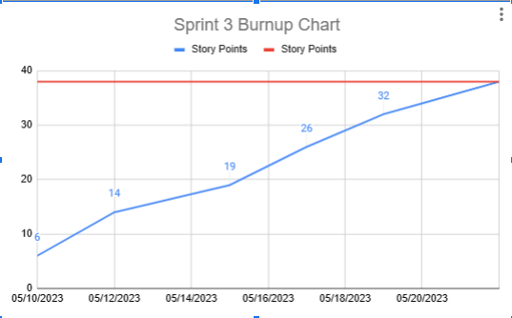

The red line is meant to be Completed